Overview:

Goal: Add a second NVMe disk to a Linux machine, put it under LVM, create two logical volumes, format them, mount them, and make the mounts persistent across reboots.

Why LVM?

- LVM (Logical Volume Manager) abstracts physical disks into flexible units. Instead of working with fixed partitions, you create Physical Volumes (PV), group them into a Volume Group (VG), and then create Logical Volumes (LV) inside that VG.
- Benefits: grow/extend volumes without repartitioning, combine disks into a single pool, take snapshots (in some setups), and easier management for servers and VMs.

Step 1 — Check available disks

Commands: #lsblk, #fdisk -l, #lsblk -f

What these do:
- lsblk lists block devices (disks/partitions) in a tree view. Shows device names, sizes, and mount points.
- fdisk -l prints partition tables for all disks (useful to see partition types).
- lsblk -f prints filesystems and UUIDs.

What you look for:
- Which disk is empty (no partitions)? In your case, /dev/nvme0n2 was empty and ~50GB.
- Which disk already has OS partitions (EFI, /boot, LVM PV)? That was /dev/nvme0n1.

Why it matters:
- You must pick a device that is safe to use (an empty disk or a disk you’re ready to wipe). If you format the wrong disk, you lose data.

Verification:
- Re-run lsblk after each major change to confirm the device layout.

Before adding the New Disk:

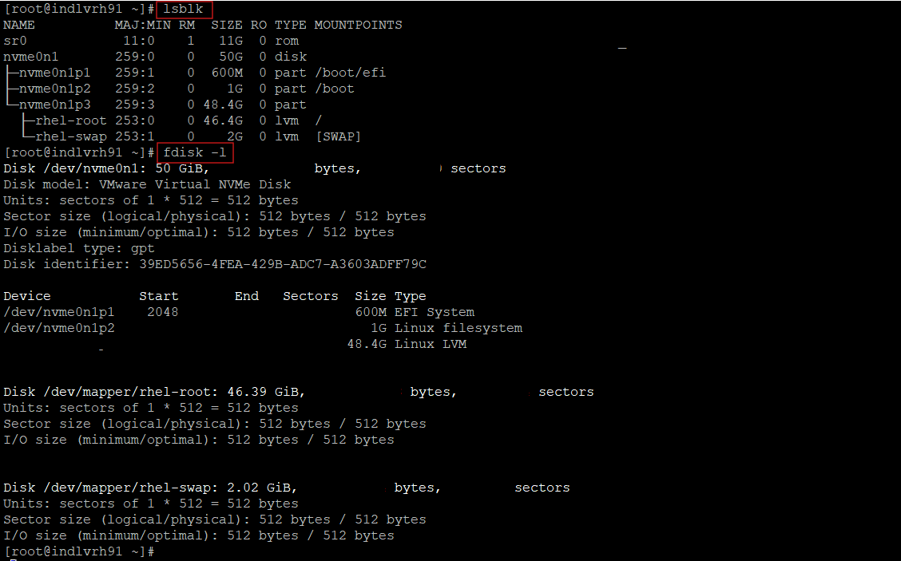

After the New Disk:

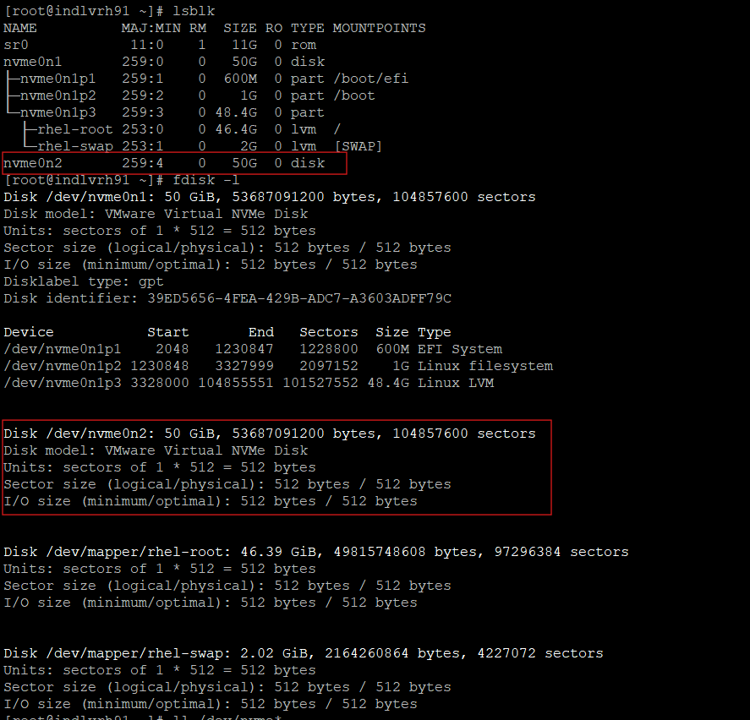

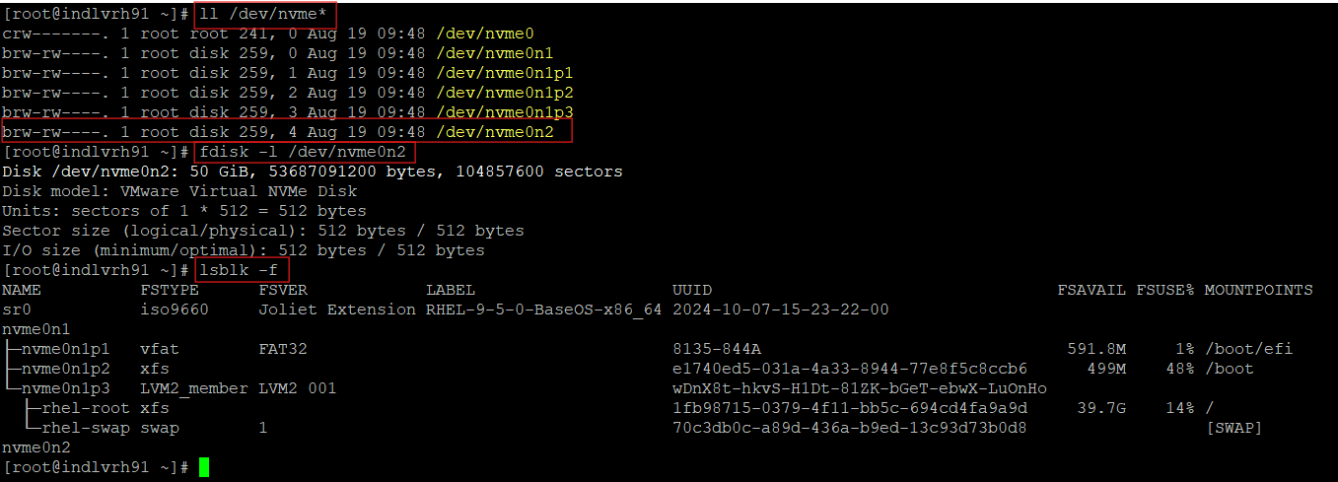

Clear explanation of Output:
- /dev/nvme0n1 is the original 50 GB disk and already has partitions:
  - nvme0n1p1 → EFI (/boot/efi)
  - nvme0n1p2 → /boot
  - nvme0n1p3 → LVM PV used by volume group rhel (which contains rhel-root and rhel-swap).
- /dev/nvme0n2 is a second 50 GB disk that is currently empty (no partitions / no filesystem).
File System Creation using LVM.

Why this matters: You can only add a disk to LVM after creating a Physical Volume (PV) on it.
Step 2 — Create a Physical Volume (PV)

Command: #pvcreate /dev/nvme0n2

What it does:
- Writes LVM metadata to the raw device LVM manages. After this, the disk is known to LVM as a Physical Volume.

Output:
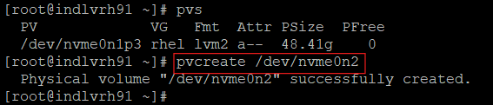
#Physical volume "/dev/nvme0n2" successfully created.

Important notes:
- Data-loss warning: pvcreate overwrites LVM metadata area and destroys any existing partition table/data on the device. Double-check the device name before running it.
- If there were a residual filesystem or prior LVM signatures, you can use wipefs or pvremove (if appropriate) — but be cautious.

Verify:
pvs # short list of physical volumes
pvdisplay # detailed info about PVs

Meaning: /dev/nvme0n2 is now usable by LVM as a PV.

Step 3 — Create a Volume Group (VG)

Command: #vgcreate vg_data /dev/nvme0n2

What it does:
Creates a named volume group (vg_data) that uses one or more PVs. The VG is the pool from which logical volumes are carved.

Result:

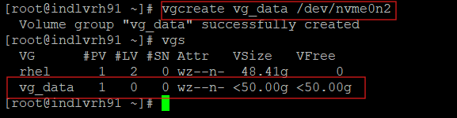
vgs will now show vg_data with roughly 50GB capacity and free space equal to the PV minus metadata.

Why VG names matter:
- Name should be descriptive and unique on the system — e.g., vg_data, vg_app, vg_home.

How to expand later:
- Add another disk later with pvcreate /dev/sdX then vgextend vg_data /dev/sdX to increase capacity.

Verify:
vgs # short list of volume groups
vgdisplay vg_data # detailed info about VGs

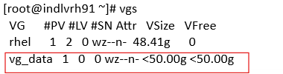

Step 4 — Create logical volumes (LVs)

Command: #lvcreate

They first created one LV of 30G:
lvcreate -L 30G -n MyScripts vg_data
# Logical volume "MyScripts" created.

Then tried to create a 20G LV and got an error:
lvcreate -L 20G -n Mintu vg_data
# Error: Volume group "vg_data" has insufficient free space (5119 extents): 5120 required.

Explanation of that error:
- LVM uses physical extents (PE) as allocation units. The VG has a certain number of PEs; a requested size in GB must be expressible as an integer number of PEs.
- The attempted -L 20G rounded up to 5120 extents, but only 5119 extents remained (off-by-one because of extent size rounding). So the explicit -L 20G failed.

To Fix:
lvcreate -l 100%FREE -n Mintu vg_data
# Logical volume "Mintu" created.

-l 100%FREE tells LVM "use whatever space is left", avoiding the rounding problem.
Outputs after success show both MyScripts (30G) and Mintu (~20G) in vg_data.

Verify:
#lvs
#lvdisplay /dev/vg_data/MyScripts

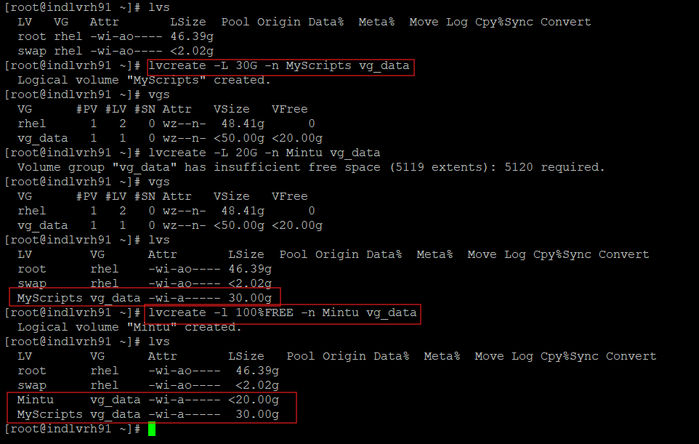

Step 5 — Create filesystems

Commands: #mkfs.ext4 /dev/vg_data/MyScripts; #mkfs.ext4 /dev/vg_data/Mintu

What it does:
- mkfs.ext4 creates an ext4 filesystem on the block device (the logical volume).
- The command outputs a UUID for the filesystem and some creation info.
Important cautions:
- This is destructive: it erases anything previously on that LV. Make sure you’re formatting the correct LV.
- ext4 is common and supports resizes (grow easily); XFS is common too but requires different grow tools.
Options & extras:
- You can set a label with mkfs.ext4 -L MyLabel /dev/vg_data/MyScripts.
- To see the newly created filesystem and UUIDs, run blkid /dev/vg_data/MyScripts or lsblk -f.

Verify:
#blkid /dev/vg_data/MyScripts
#lsblk -f

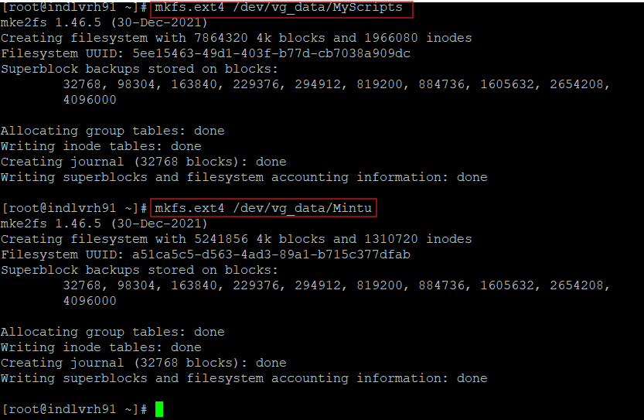

Step 6 — Make mount directories and mount the LVs

Commands: mkdir -p ; mount <device> <mountpoint> ;df -h

What these do:
- mkdir -p creates the mount point directories; -p makes parent directories as needed and won’t error if they already exist.
- mount <device> <mountpoint> attaches the filesystem to the directory tree so you can access it under /myscripts and /mintu.
- df -h shows mounted filesystems with human-readable sizes (G, M).

Common mistakes:
- Running mount -a (which mounts everything in /etc/fstab) will fail for any fstab entry whose mount point does not exist. Always create mount point directories first.
- Typo like mount-a (no space) yields “command not found” — trivial but common.

Verify:
- findmnt shows mount hierarchy and source/target.
- lsblk -f shows which devices are mounted were.
- Check permissions: the default owner is root; change ownership with chown if users need access.

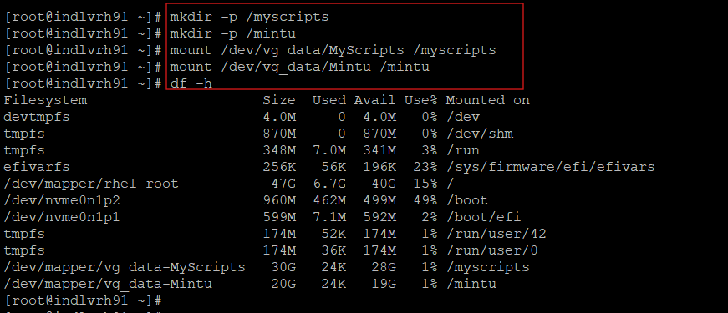

Step 7 — Record UUIDs and update /etc/fstab

Workflow:

Get each filesystem’s UUID:
# blkid /dev/vg_data/MyScripts
# ls -l /dev/disk/by-uuid/

Add lines to /etc/fstab using the UUIDs:
UUID=5ee15463-49d1-403f-b77d-cb7038a909dc /myscripts ext4 defaults 0 2
UUID=a51ca5c5-d563-4ad3-89a1-b715c377dfab /mintu ext4 defaults 0 2

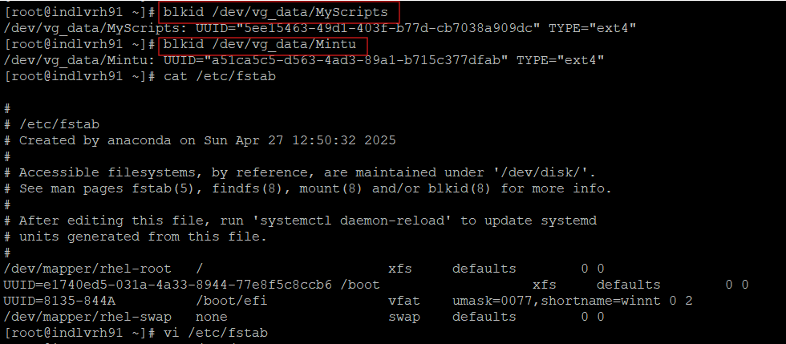

Breakdown of an /etc/fstab line:
- fs_spec: UUID=... — identifies the device. Alternatives: /dev/mapper/vg_data-MyScripts or /dev/nvme0n2p1, but UUIDs are most stable.
- fs_file: mount point (/myscripts).
- fs_vfstype: filesystem type (ext4).
- fs_mntops: mount options (e.g., defaults, or noatime, nodev, etc.)
- fs_freq (dump): usually 0 for modern systems (used by dump utility).
- fs_passno (fsck order): 1 for root filesystem, 2 for other filesystems; 0 disables fsck.

Extra note:
- systemctl daemon-reload reloads systemd unit files and is not required to reload /etc/fstab. It’s harmless but unnecessary for fstab changes. mount -a is the key command for testing fstab entries immediately.

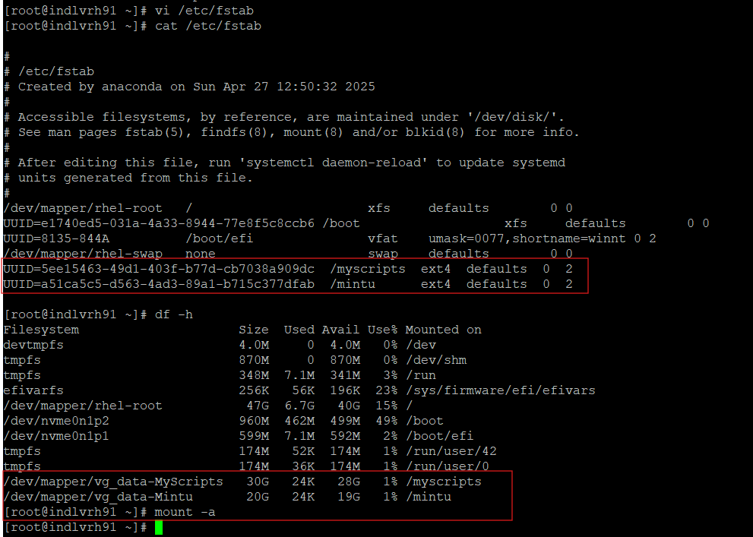

Best practices
- Always backup important data before mkfs or destructive operations.
- If lvcreate -L <size> fails with "insufficient extents", use lvcreate -l 100%FREE or check vgdisplay to see exact free PEs and PE size.
- Use pvs, vgs, and lvs to inspect LVM state:
  - pvs shows physical volumes
  - vgs shows volume groups and free space
  - lvs shows logical volumes
- When resizing LVs later:
  - To grow an ext4 FS: lvextend -L +10G /dev/vg_data/MyScripts then resize2fs /dev/vg_data/MyScripts.
  - To grow an XFS FS: lvextend -L +10G /dev/… then xfs_growfs /mountpoint.
- Always ensure the mount point directory exists before mount -a or boot-time mounting will fail.
- Using filesystem UUIDs in /etc/fstab is more robust than device paths.
- If you add another physical disk to expand the VG later, use pvcreate /dev/sdX then vgextend vg_data /dev/sdX.

